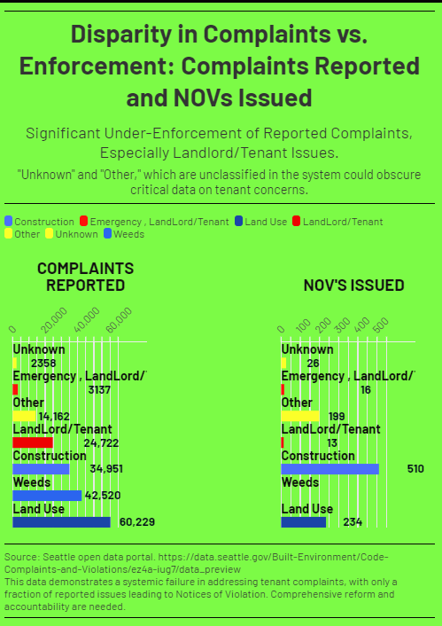
Case Study: Everspring Inn – A Pandemic-Era Betrayal of Public Trust
Overview
In August 2020, while Seattle's eviction moratorium was in full effect, the Everspring Inn at 8201 Aurora Ave N became the epicenter of a mass eviction that exposed not just a landlord’s misconduct—but the utter collapse of the City’s regulatory safeguards. Approximately 25 long-term tenants, many of them elderly, disabled, or medically vulnerable, were illegally evicted without court orders, due process, or relocation assistance. Meanwhile, the property owner, Ryan Kang, was reportedly receiving financial assistance from the State of Washington.
Timeline of Events
- August 1, 2020: Kang posts informal eviction notices citing an SPD agreement.- August 6, 2020: SPD signs a nuisance abatement agreement, used as retroactive cover.- August 18, 2020: Thirteen tenant complaints filed with SDCI. All complaints labeled “Just Cause Eviction” and “COVID19-X.” All marked “Voluntary Compliance” and closed shortly after with no inspection.- August 25, 2020: SDCI spokesperson Bryan Stevens states: “We are reviewing the matter.”
Personnel Involved
- Stella Washington (SDCI)- Shantell McEachin (SDCI)- Bryan Stevens (SDCI Spokesperson)These individuals oversaw and publicly defended the closure of all 13 complaints without inspection or enforcement.
SPD’s Role
SPD signed a nuisance abatement agreement on August 6, 2020—five days after evictions began. Kang weaponized this signature to threaten tenants. SPD admitted later that they took no enforcement action on site, but the document served to legitimize the eviction.
SDCI’s Inaction
Despite internal tagging as 'Just Cause Eviction' and 'COVID19-X,' no inspections were conducted, and all complaints were closed as 'Voluntary Compliance.'
Tenant Impact
- At least 13 tenants displaced- Pregnant woman hospitalized- Disabled tenant evicted while caring for terminal partner- No tenant relocation assistance provided- Ryan Kang accepted state aid during this period
Conclusion
The Everspring Inn case shows catastrophic failure by both SPD and SDCI.SPD enabled. SDCI excused. The city looked away.Tenants were erased while the landlord was rewarded.This is why SDCI must be stripped of enforcement authority.
Demands
1. Full investigation into SDCI’s handling of all thirteen complaints2. Release of SDCI internal records and logs3. Personnel review of Stella Washington, Shantell McEachin, Bryan Stevens4. Establishment of the Seattle Tenant Landlord Compliance Authority (STLCA)

